## CHIP - Refresh protocol

This protocol outlines the required new steps to refresh a CHIP dashboard. This will be annually, or on request.

Much of CHIP is configured to automatically update to a new five-year period on refresh. However, due to the construction of the treatment summary tables in the non-trachoma pages, these will need to be manually configured.

### Annual refresh

#### Step 1: Refresh and update all tables

In Power Query Editor, refresh each query so the latest year of data is present in the dataset. You will need to add the new year to ‘Changed all types.’

#### Step 2: Check for cartographic update

If there has been administrative adjustments in the last year, new cartography will need to be created and updated per each map. See onboarding protocol for further guidance.

#### Step 3: Update year of endemicity

As maps/tables show by default the most recent year, update in each dashboard accordingly. This includes the country page header row, and the automated map title in the WASH dashboard. To update the WASH dashboard, open measure ‘WASH title’ and update year in code.

#### Step 4: Add new year of data to treatment summary tables

Remove the oldest year of data and add the new year to the treatment summary table. Ensure you update the filters accordingly to remove the old year and re-order.

You will need to add conditional formatting for the new year of data. In the format menu, select Conditional formatting, then the new year of data in the drop down.

You will need to update both background and font colour. Click the link ‘Advanced controls’ in turn for each.

#### 

Background colour should be set as per this screenshot, substituting 75 for 65 in the case of schistosomiasis and STH. Refer to the CHIP codebook for colour HEX codes.

#### 

Font colour should be set as per this screenshot.

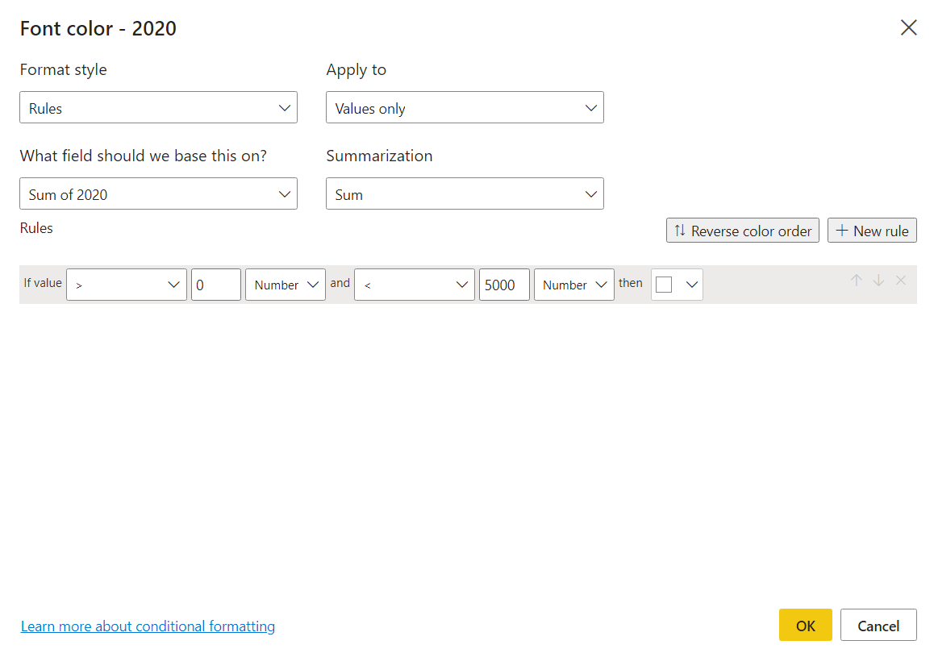

#### Step 5: Update references page

Revise CHIP release by adding a .1 to the version number. If the annual refresh has coincided with a CHIP version update, update the version number, and set release to ‘.0’.

Revise ‘Last CHIP update’ on the CHIP reference page.

#### Step 6: Republish dashboard

Follow the steps in the onboarding new countries protocol to republish the dashboard.

### On-request refresh

#### Step 1: Refresh and update all tables

In Power Query Editor, refresh each table so the latest data is loaded to the dataset.

#### Step 2: Update references page

Revise CHIP release by adding a .1 to the version number.

Revise ‘Last CHIP update’ on the CHIP reference page.

#### Step 3: Republish dashboard

Follow the steps in the onboarding new countries protocol to republish the dashboard.